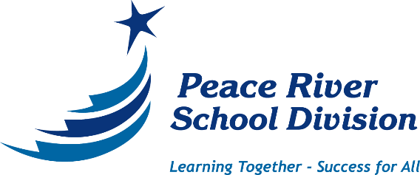

E.E. Oliver Elementary School 2021-2024
Education Plan
School vision: An inclusive, inspiring, learning focused community that equips students for their most successful future.
School mission: The EEO community will provide an atmosphere where there are high expectations for learning, using a holistic, flexible, and responsive plan with a future oriented mindset.
School values:
Excellence: To strive for the highest quality of one’s ability
Achievement: To set or attain a specific goal or purpose
Growth: To improve and change for a positive purpose
Leadership: To promote, guide and demonstrate a positive and caring direction with integrity
Empathy: To demonstrate sympathetic understanding of another
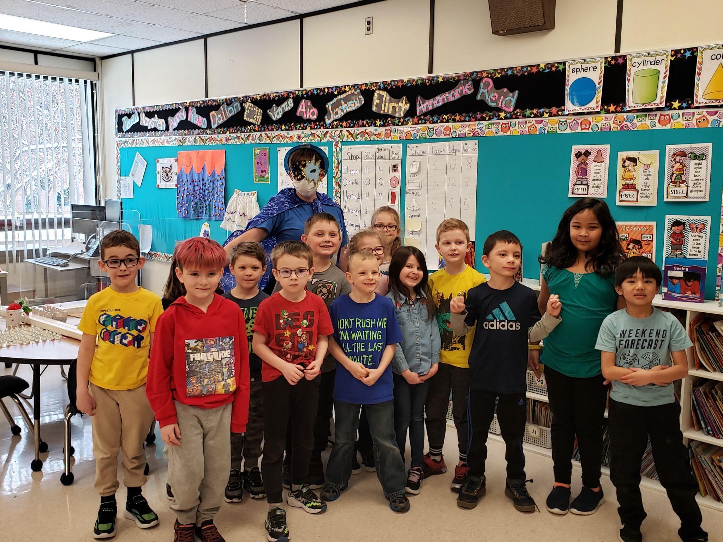
Safety: To keep others and self free from harm, injury or danger

PEACE RIVER SCHOOL DIVISION PRIORITIES
1. Literacy development/achievement
2. Numeracy development/achievement
3. Inclusionary and responsive culture

GOAL ONE - All students are literate.
Outcome: All students are reading and writing at or above grade level or meeting their individualized program goals.
GOAL TWO - All students are numerate.
Outcome: All students are performing at or above grade level in numeracy or meeting their individualized program goals.
Performance measures for Goals One and Two - Literacy and Numeracy:
- (PRSD) The percentage of Grades 1-8 students reading at or above grade level as per achievement on Fountas and Pinnell assessment measures including comprehension, fluency and accuracy;
- (PRSD) The percentage of students reading at or above grade level as per achievement on the Grades 4 to 12 Reading Comprehension Assessment Tool (RCAT);
- (PRSD) The percentage of Grades 1-9 students writing at or above grade level as per achievement on the division’s writing assessment tool;
- (PRSD) The percentage of Grades 2-10 students achieving an “acceptable standard” or “standard of excellence” on the Grades 1-9 Math Intervention/Programming Instrument (MIPI);
- (PRSD) The percentage of Grades 1-9 students achieving “meeting’ or “meeting with mastery” on the Numeracy Common Assessment Tool (NCAT);
- (PRSD) The percentage of students “meeting” or “meeting with mastery” the English Language Arts and Mathematics learner outcomes as per report card data by grade level;
- (ABEd) The percentage of students/First Nations, Métis, and Inuit students achieving the “acceptable standard” and “standard of excellence” on Grade 6 and Grade 9 English Language Arts PATs and Mathematics PATs;
- (ABEd) The percentage of students/First Nations, Métis, and Inuit students achieving the “acceptable standard” and “standard of excellence” on English Language Arts Diploma Exams and Mathematics Diploma Exams.

E.E. Oliver School strategies for Goal One – Literacy:
- Implement and utilize the Empowering Writers program across all grade levels
- Seek out and implement a consistent phonics program across all grade levels
- Implement and utilize Heggerty Phonemic Awareness program classwide in K-2 and as an intervention for students as needed
- Hold Intervention planning meetings every two months to evaluate programs and student progress
- Embed PLC time in the school schedule to learn about effective literacy practices
- Teachers will continue to conduct, analyze, and use school wide, divisional literacy assessments (RAF and BAS) to provide benchmarks for student programming and flexible grouping to guide Collaborative Response
- Teachers will provide programming options to best meet learner needs (flexible groupings, LLI, guided reading groups, differentiated instruction)
- Regularly scheduled grade level Collaborative Response Team Meetings (grade level teachers, administration and I Coach) will continue to be held to review student data and implement strategies for students
- Teachers will continue to develop and improve learner profiles to identify student needs as part of a continuum of supports using the Collaborative Response Application in Dossier

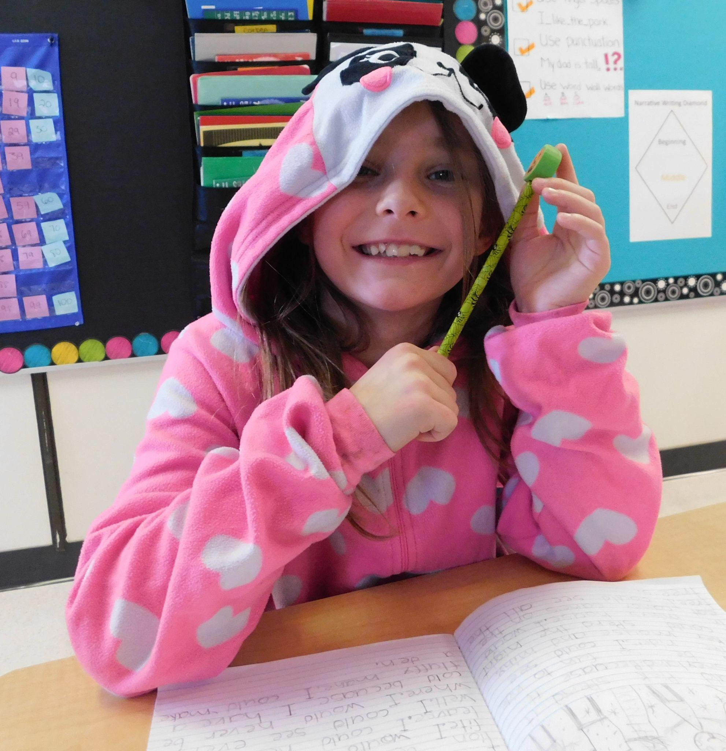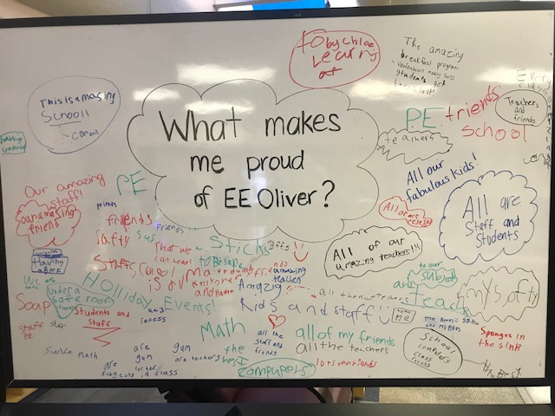

E.E. Oliver School strategies for Goal Two – Numeracy:
- Implement a common Scope and Sequence for instruction at each grade level
- Utilize the Concrete-Pictorial-Abstract approach to develop conceptual understanding of abstract topics
- Develop fact fluency through use of foundational facts and reasoning strategies during activities and games (including those that are technology based)
- Teachers will use problem solving and real life applications to build conceptual understanding and build mathematical connections
- Teachers will conduct, analyze, and use school wide, divisional numeracy assessments (MIPI and NCATs) to provide benchmarks for student programming to guide Collaborative Response
- Embed PLC time in the school schedule to learn about effective numeracy practices.
- Regularly scheduled grade level Collaborative Response Team Meetings (grade level teachers, administration and I Coach) will continue to be held to review student data and implement strategies for students
- Explore ways to make numeracy more visible in the school

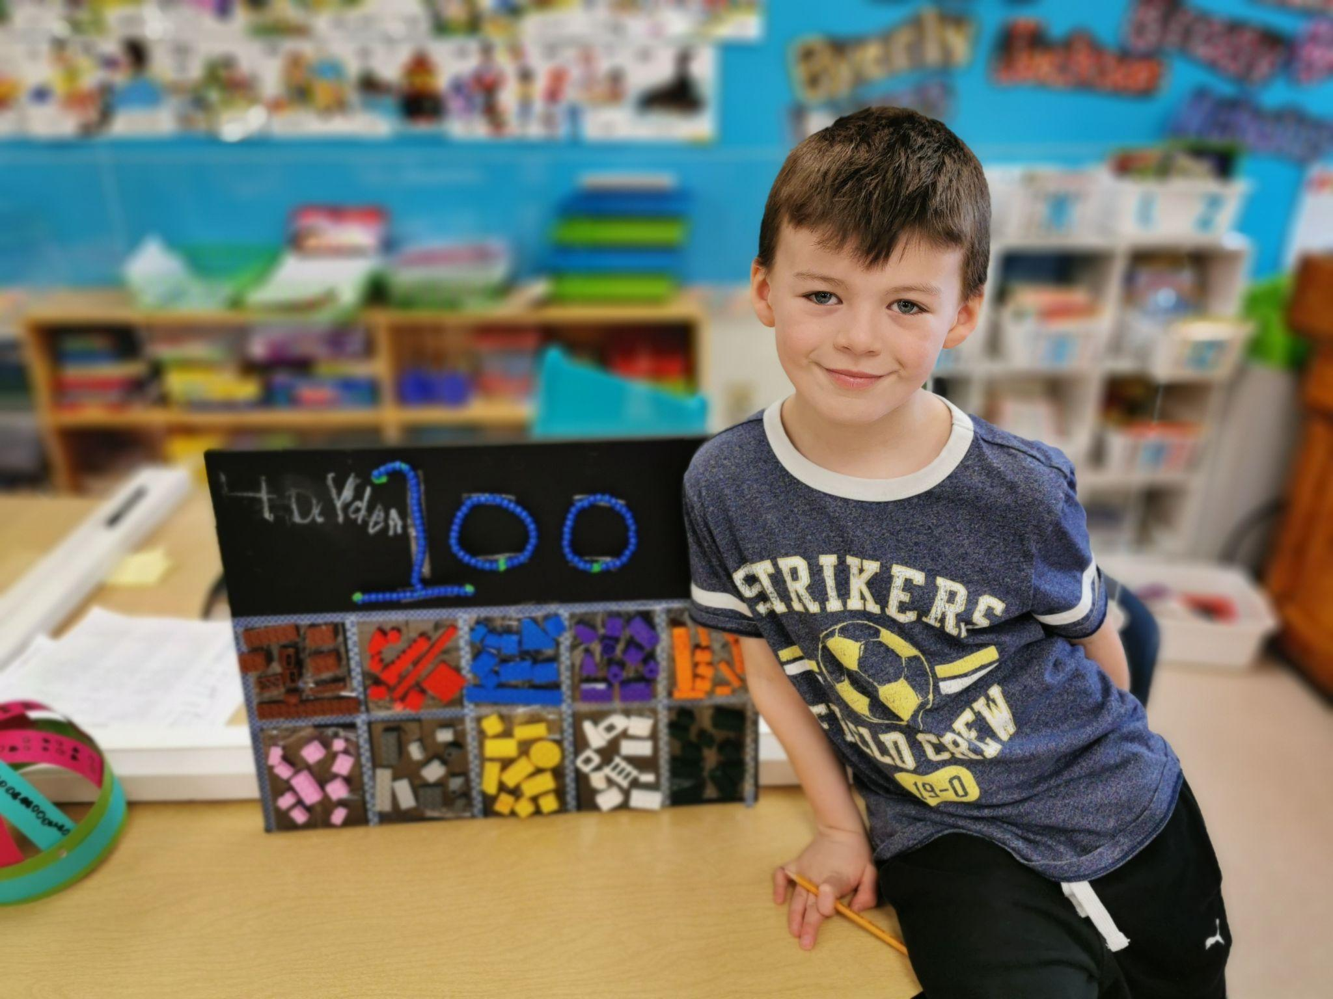

GOAL THREE – All students are successful through inclusionary practices in an engaging culture.
Outcome 3.1: Inclusive Education
Students are meeting high expectations in learning outcomes that reflect their individual academic needs and interests.
Outcome 3.2: Wellness and Student Engagement
Students’ physical and social-emotional wellness needs and interests are met and their academic engagement is increased by ensuring a safe and caring environment that celebrates diversity.
Performance measures for Inclusionary Practices in a Responsive Culture:
- (PRSD) The percentage of students receiving individualized programming services;
- (PRSD) The percentage of students with special education needs who are being supported by appropriate documentation such as Individual Program Plans (IPP) and Behaviour Support Plans (BSPs);
- (PRSD) The percentage of students who are absent less than ten percent of the time during the school year;
- (PRSD) The percentage of schools that implemented strategies to address the top five most important issues expressed by students in the 2021 Student Mental Health and Wellness Survey;
- (ABEd) Percentage of teachers, parents, and students satisfied with the opportunity for students to receive a broad program of studies including fine arts, careers, technology, and health and physical education;
- (ABEd) The percentage of teachers, parents and students satisfied with the overall quality of basic education;
- (ABEd) The percentage of teachers and parents who agree that students are taught attitudes and behaviours that will make them successful at work when they finish school;
- (ABEd) The percentage of teacher and parent satisfaction that students demonstrate the knowledge, skills and attitudes necessary for lifelong learning;
- (ABEd) Annual drop-out rate for students/First Nations, Métis, and Inuit 9. students aged 14 to 18;
- (ABEd) The percentage of teacher, parent, and student agreement that: students are safe at school, are learning the importance of caring for others, are learning respect for others and are treated fairly in school.

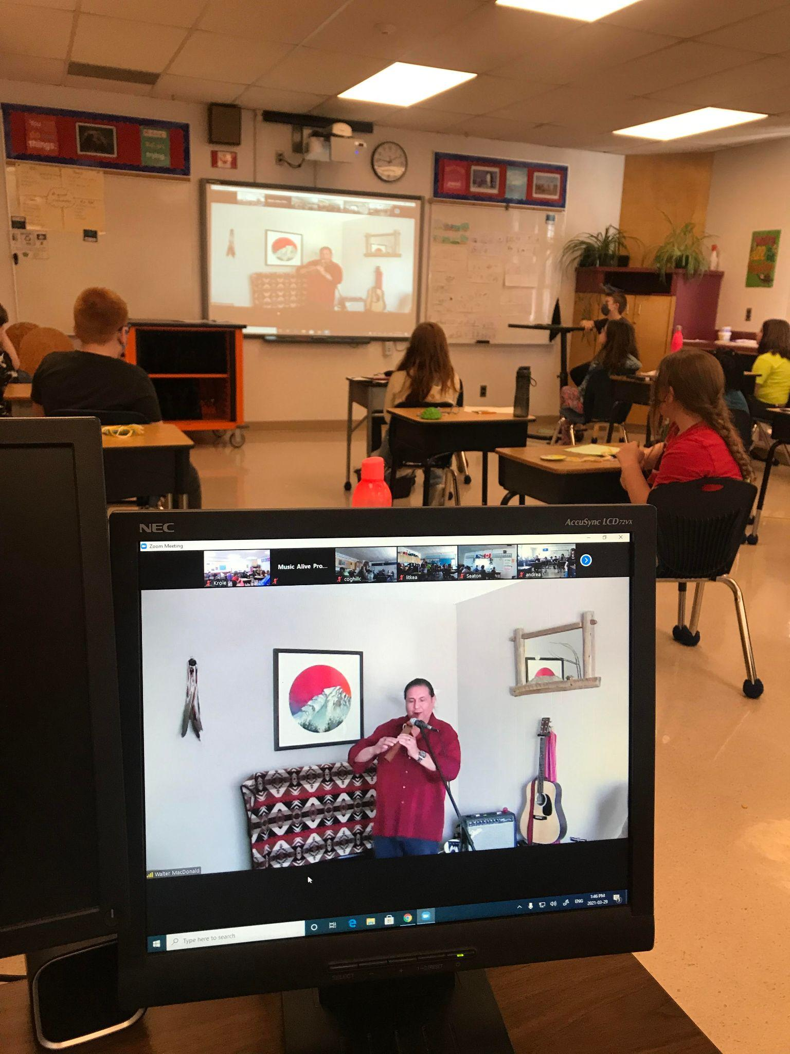
School strategies for Goal Three:
Inclusionary and Responsive Culture
- Ensure that I coaches, Teachers and Admin team are aware of each of their roles and support each other
- I coaches, Teachers and Admin will regularly review supports and plans (IPP, BSP, MSP, ESP) to ensure individual needs are being met
- Teachers will provide programming options to best meet learner needs (flexible groupings, LLI, guided reading groups, differentiated instruction) with the assistance and support of school and divisional I coach, as well as school based learning support teams
- Targeted classrooms will receive programming by the Family School Liaison that contribute to improving school climate and student well-being and safety
- Diversity will be celebrated through teachings in each classroom as well as school wide activities (Orange shirt day, Mental Health day, wellness activities etc)
- The PBIS plan will be used to encourage prosocial behaviour that contributes to a positive learning environment for all
- The sensory rooms and classroom regulation activities will be utilized so students are ready to meet academic goals
- Regularly scheduled grade level Collaborative Response Team Meetings (grade level teachers, administration and I Coach) will continue to be held to review student data and implement strategies for students
- Utilize the EAGLE Award to promote safe, caring and respectful behaviours
- Teachers will periodically contact parents to provide encouragement and support for school attendance.

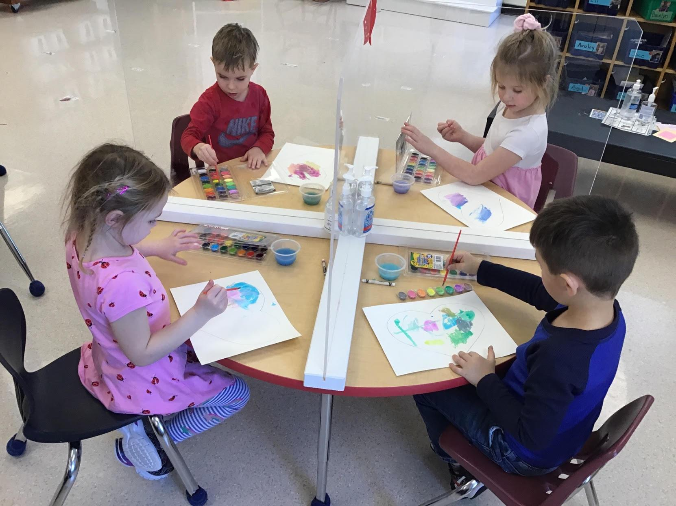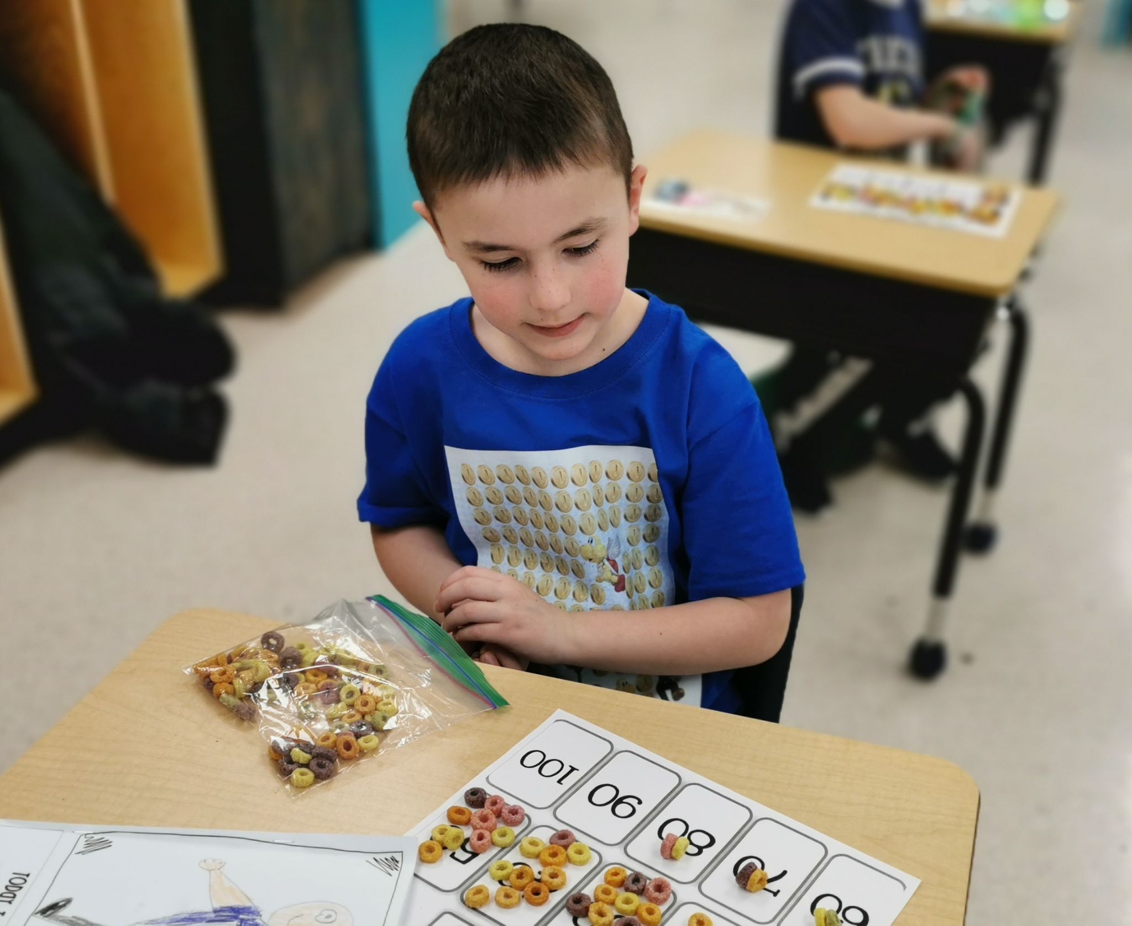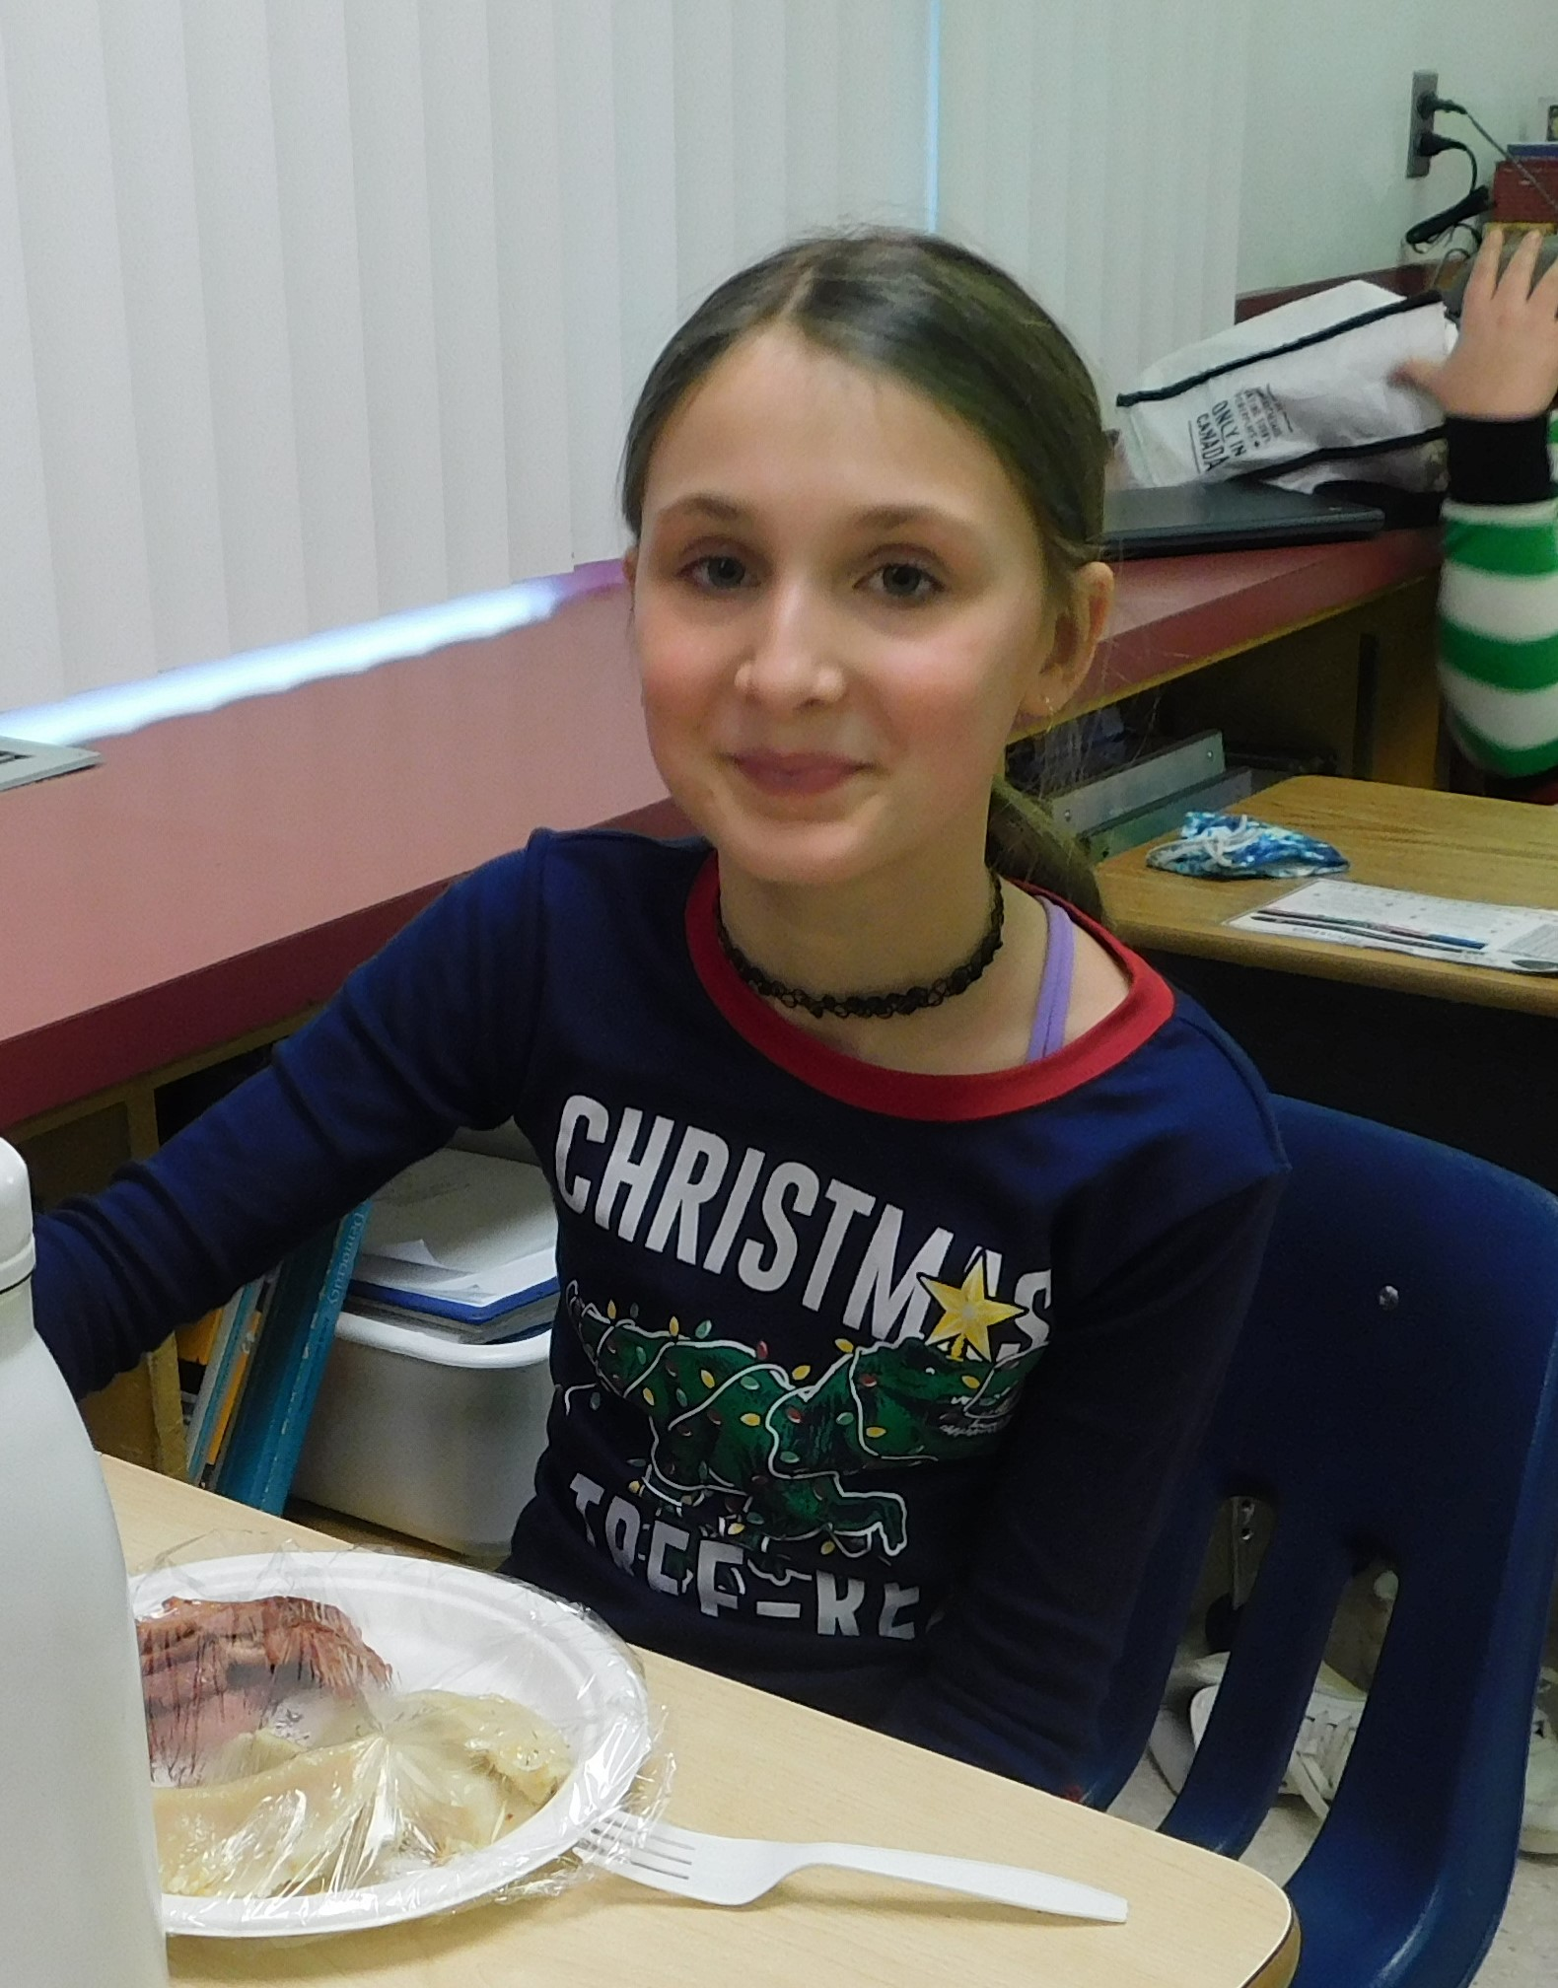

School Budget Considerations
General
- General supplies necessary for the day-to-day operation of a school: $22 000
- Breakfast and lunch supplies for the nutrition program: $20 000
- Classroom supplies which enhance the learning experiences of our children: $15 000
Goal One: All students are literate
- Phonics programming resources: $10 000
- Empowering Writer’s Resources: $3 000
- Professional Development: $4 000
Goal Two: All students are numerate
- Technology program fees: $6 000
- Continue to acquire classroom numeracy games and manipulatives: $2 000
- Professional development: $4 000
Goal Three: All students are successful through inclusionary practices in a responsive and engaging culture
- Continue to support resources for our sensory rooms: $1 500
- Acquire resources necessary to support students in their classrooms: $1 500
- Professional Development: $4 000

