30-day Love your body challenge
Color in every square you have completed. The class with the most days completed will win a class reward!

10 star jumps | Jog on the spot for 2 minutes | 10 squats  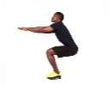 | Try a headstand | 5 push ups  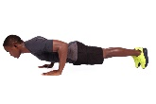 | Jump on the spot 20 times
Eat vegetables! | 5 sit ups | Do the yoga tree pose | Squat and jump 5 times | 10 jumping jacks | Balance on one leg for 30 seconds
Hop on your right leg as long as you can! | Hop on your left leg as long as you can! | Spin in a circle 10 times | Meditate. Lay down and close your eyes and stay still using big breaths. | Try a backbend | Play outside for 30 minutes
Crab walk | 20 lunges | Plank for as long as you can! | Do a cartwheel  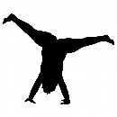 | 5 burpees | 20 butt kicks
10 sit ups | Turn on some music and dance! | Do your favorite deep breathing exercise | Drink 4 glasses of water today | Do the yoga child’s pose  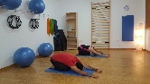 | Run on the spot for 30 seconds

